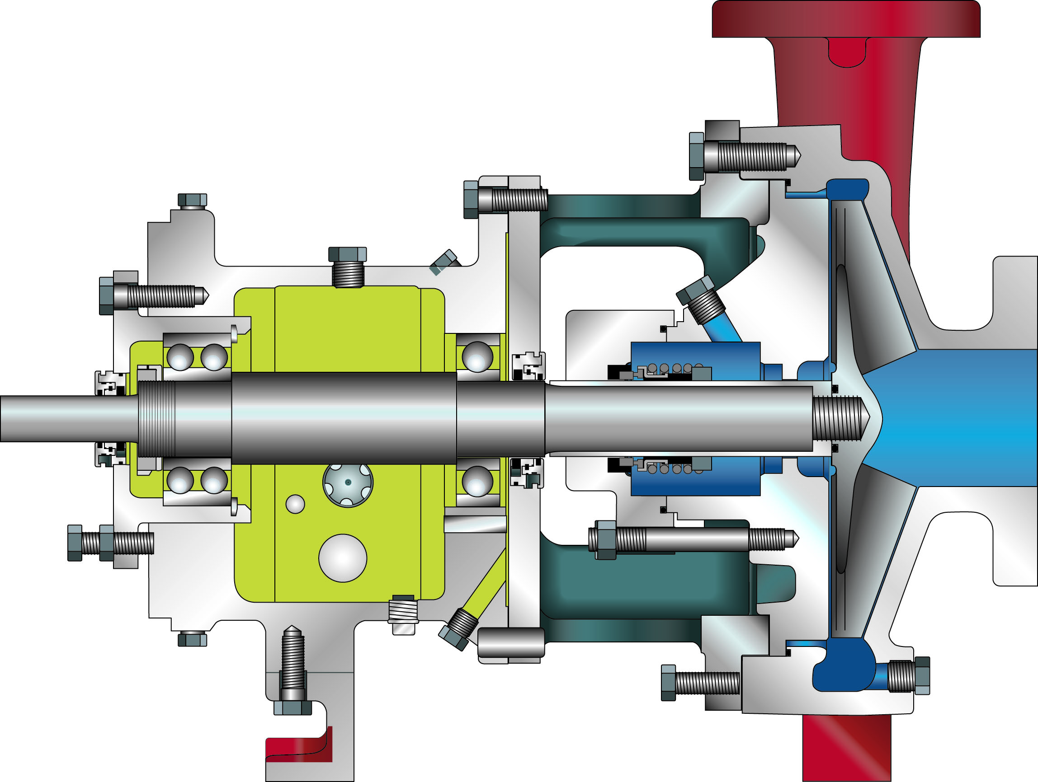
The advanced design and precision manufacture of the rugged, heavy-duty OSG ANSI process pump provide long-term reliable performance and significantly enhance bearing and seal life. American-Marsh Pumps is committed to helping users maximize mean time between planned maintenance (MTBPM). American-Marsh Pumps’ unique features and enhancements provide significant performance benefits for pump users. Some features of the OSG resulted from the suggestions of working engineers in the field, and were combined with others derived from the broad experience of American-Marsh engineers. Thus practical features, backed by over 130 years of quality pump manufacturing, assure you of excellent pump performance and full satisfaction.
PRODUCT BULLETINCOMMERCIALINDUSTRIAL
MODEL OSG ANSI PROCESSBoiler Feed, Transfer,Propane, Butane, Crude Oil, Acids, Gasoline, Naphtha, Organic,
Condensate ReturnPetrochemical, Black Liquor, Ammonia, Organic Fluids, Cargo Transfer
PRODUCT BULLETIN
MODEL OSG ANSI PROCESS

PART | CONSTRUCTION
PART | DUCTILE IRON | DUCTILE IRON  316 SS FITTED | ALL 316 SS | ALL CD4MCU | ALL ALLOY 20
Casing | DUCTILE IRON | DUCTILE IRON | 316 SS | CD4MCU | ALLOY 20
Impeller | DUCTILE IRON | 316 SS | 316 SS | CD4MCU | ALLOY 20
Shaft | STEEL | 316 SS | 316 SS | STEEL | STEEL
Seal Chamber | DUCTILE IRON | DUCTILE IRON | 316 SS | CD4MCU | ALLOY 20
Seal Gland | 316 SS | 316 SS | 316 SS | ALLOY 20 | ALLOY 20
Power Frame | CAST IRON | CAST IRON | CAST IRON | CAST IRON | CAST IRON

Casing: The casing is constructed of high tensile ductile iron or other specified material. It is of the volute type, carefully and accurately proportioned to permit smooth flow and to convert high velocity energy of the fluid as it leaves the impeller into pressure. Suction and discharge nozzles are flanged and are cast integral with the volute. The casing has cast integral feet standard and the discharge port is of the vertical centerline type. The casing assembly fully meets ANSI B73.1 dimensional requirements. Necessary vent and drain openings can be provided upon request.
Impeller: The impeller is of the fully open, end suction type, casted in one piece of cast steel or other specified material. This design allows for greater wear area for longer life, renewable performance for reduced repairs, and minimum hydraulic loads. All impellers are hydraulically and dynamically balanced prior to assembly. All model meets the stringent performance requirements of ANSI B73.1
Shaft: The shaft is of high strength steel or other specified material, ground to accurate dimensions and polished to a smooth surface. It is designed for extra stiffness to avoid all critical speeds in operation. OSG pumps lead the industry in low L³/D⁴ ratio’s minimizing shaft deflection at the stuffing box. All OSG models guarantee less than 0.002” shaft deflection at the seal face location, while in operation. As an option, the shaft can be protected by a shaft sleeve of ample thickness to ensure long life. The shaft sleeve can be supplied in various materials.
Seal Chamber: The seal chamber is available in two (2) different configurations depending on the jobsite requirement. OSG pumps feature the Standard Bore seal chamber designed for packing and accommodates mechanical seals. The Large Taper Bore is also avaliable for increased seal life through improved lubricastion and cooling. Both are designed to meet the process requirements of the seal industry. Seal chambers have provisions for various flush plan arrangements customizing the seal chamber to meet the requirements of the end user. For abrasive applications, packing with a lantern ring can also be supplied. A wide variety of component and cartridge mechanical seals can be used with OSG standard components.
Power Frame: The power frame is constructed of cast iron and provides support for the inboard and outboard bearings. The outboard bearing is of the double row, angular contact type and the inboard bearing is of the single row, deep groove type for excellent axial and radial load support. For axial adjustment of the impeller, the power frame employs a micrometer adjustment which allows the user to dial back factory tolerances between the impeller and the pump casing. This re-adjustment of tolerances can be done on the bench, compensating for proper seal setting and eliminating the need to have the casing near for final adjustment. Double lip seals ensure that contaminents are kept out of the power frame. Upgraded bearing isolators can be supplied upon request. For extremely crucial applications, magnetic bearing isolators with a poppet breather can be specified, hermetically sealing the power frame. The power frame has an oversized, integral oil sump that provides oil for lubrication to each bearing. A large one inch oil level eye is provided standard on the power frame to visually indicate the oil level. The bearings and shafts are so designed to last up to 61% longer than the competition. With shaft deflection indicies surpassing nearly all of the competition, 43-252% greater stiffness is achieved resulting in longer Mean Time Between Planned Maintenance (MTBPM).

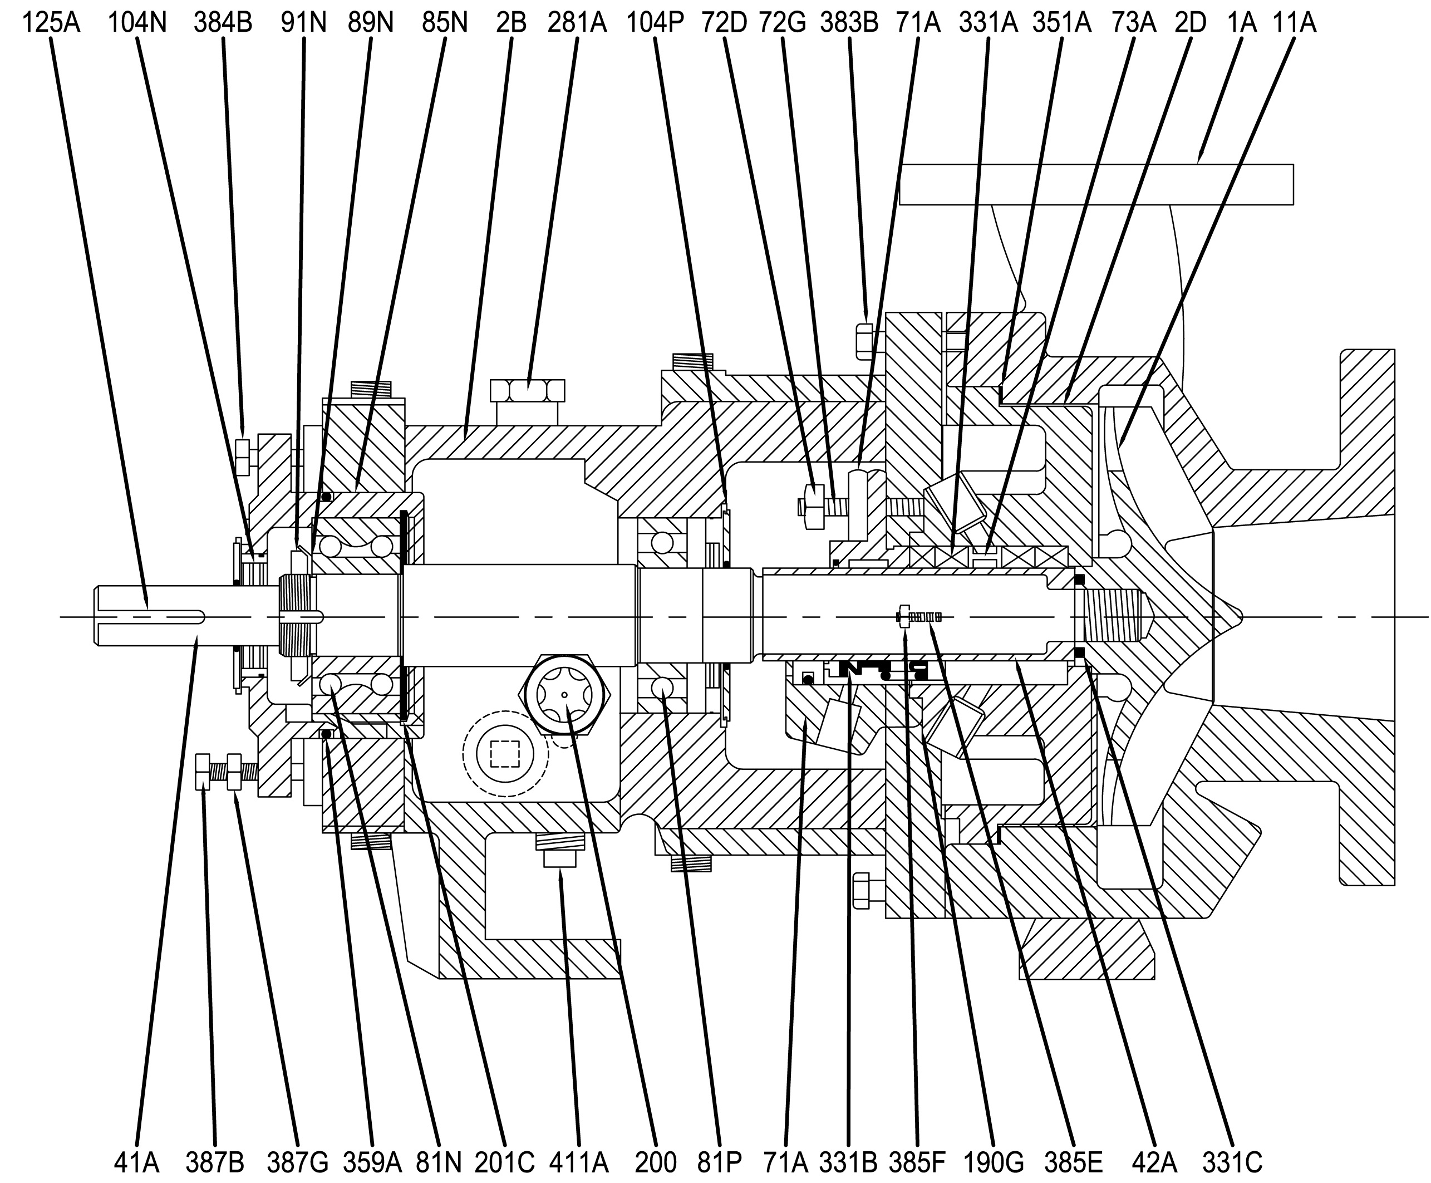

Item Number | Item Description | Num. Req. |  | Item Number | Item Description | Num.  Req.
1A | Casing |  |  | 125A | Coupling Key
2B | Bearing Housing |  |  | 190G | Stuffing Box Gland Gasket
2D | Rear Cover |  |  | 200 | Sight Gauge
11A | Impeller |  |  | 201C | Bearing Carrier Retainer
41A | Shaft |  |  | 281A | Bearing Housing Vent Plug
42A | Shaft Hook Sleeve |  |  | 331A | Packing
71A | Stuffing Box Gland |  |  | 331B | Mechanical Seal
72D | Gland Nut |  |  | 331C | Impeller O-Ring
72G | Gland Stud |  |  | 351A | Casing Gasket
73A | Lantern Ring |  |  | 359A | Bearing Carrier O-Ring
81N | Outboard Bearing, Thrust |  |  | 383B | Casing Bolt
81P | Inboard Bearing, Radial |  |  | 384B | Bearing Carrier Bolt
85N | Bearing Carrier |  |  | 385B | Casing Jacking Bolt
89N | Outboard Bearing Lockwasher |  |  | 385E | Rear Cover Stud
91N | Outboard Bearing Locknut |  |  | 385F | Rear Cover Nut
104N | Outboard Lip Seal |  |  | 387G | Bearing Housing Jam Nut
104P | Inboard Lip Seal |  |  | 411B | Bearing Housing Drain Plug
Recommended spare parts are in BOLD.

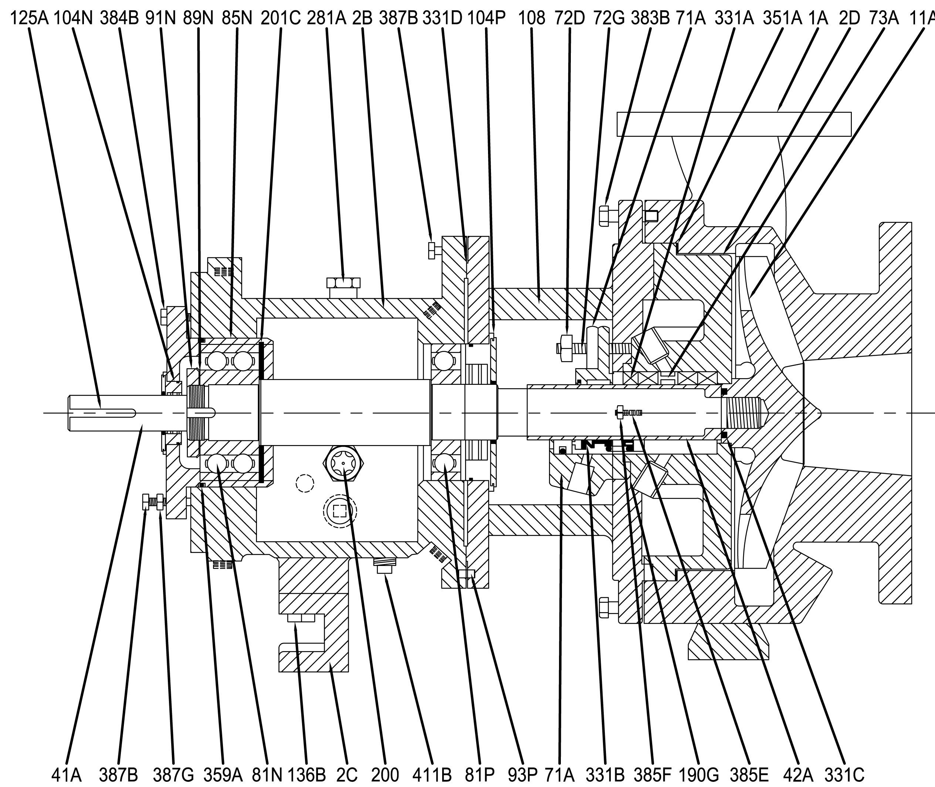

Item Number | Item Description | Num. Req. |  | Item Number | Item Description | Num.  Req.
1A | Casing |  |  | 125A | Coupling Key
2B | Bearing Housing |  |  | 136B | Bearing Housing Foot Capscrew
2C | Bearing Housing Foot |  |  | 190G | Stuffing Box Gland Gasket
2D | Rear Cover |  |  | 200 | Sight Gauge
11A | Impeller |  |  | 201C | Bearing Carrier Retainer
41A | Shaft |  |  | 281A | Bearing Housing Vent Plug
42A | Shaft Hook Sleeve |  |  | 331A | Packing
71A | Stuffing Box Gland |  |  | 331B | Mechanical Seal
72D | Gland Nut |  |  | 331C | Impeller O-Ring
72G | Gland Stud |  |  | 331D | Bearing Housing Gasket
73A | Lantern Ring |  |  | 351A | Casing Gasket
81N | Outboard Bearing, Thrust |  |  | 359A | Bearing Carrier O-Ring
81P | Inboard Bearing, Radial |  |  | 383B | Casing Bolt
85N | Bearing Carrier |  |  | 384B | Bearing Carrier / Housing Bolt
89N | Outboard Bearing Lockwasher |  |  | 385B | Casing Jacking Bolt
91N | Outboard Bearing Locknut |  |  | 385E | Rear Cover Stud
93P | Bearing Housing Dowel Pin |  |  | 385F | Rear Cover Nut
104N | Outboard Lip Seal |  |  | 387G | Bearing Housing Jam Nut
104P | Inboard Lip Seal |  |  | 411B | Bearing Housing Drain Plug
108 | Bearing Housing Adapter
Recommended spare parts are in BOLD.

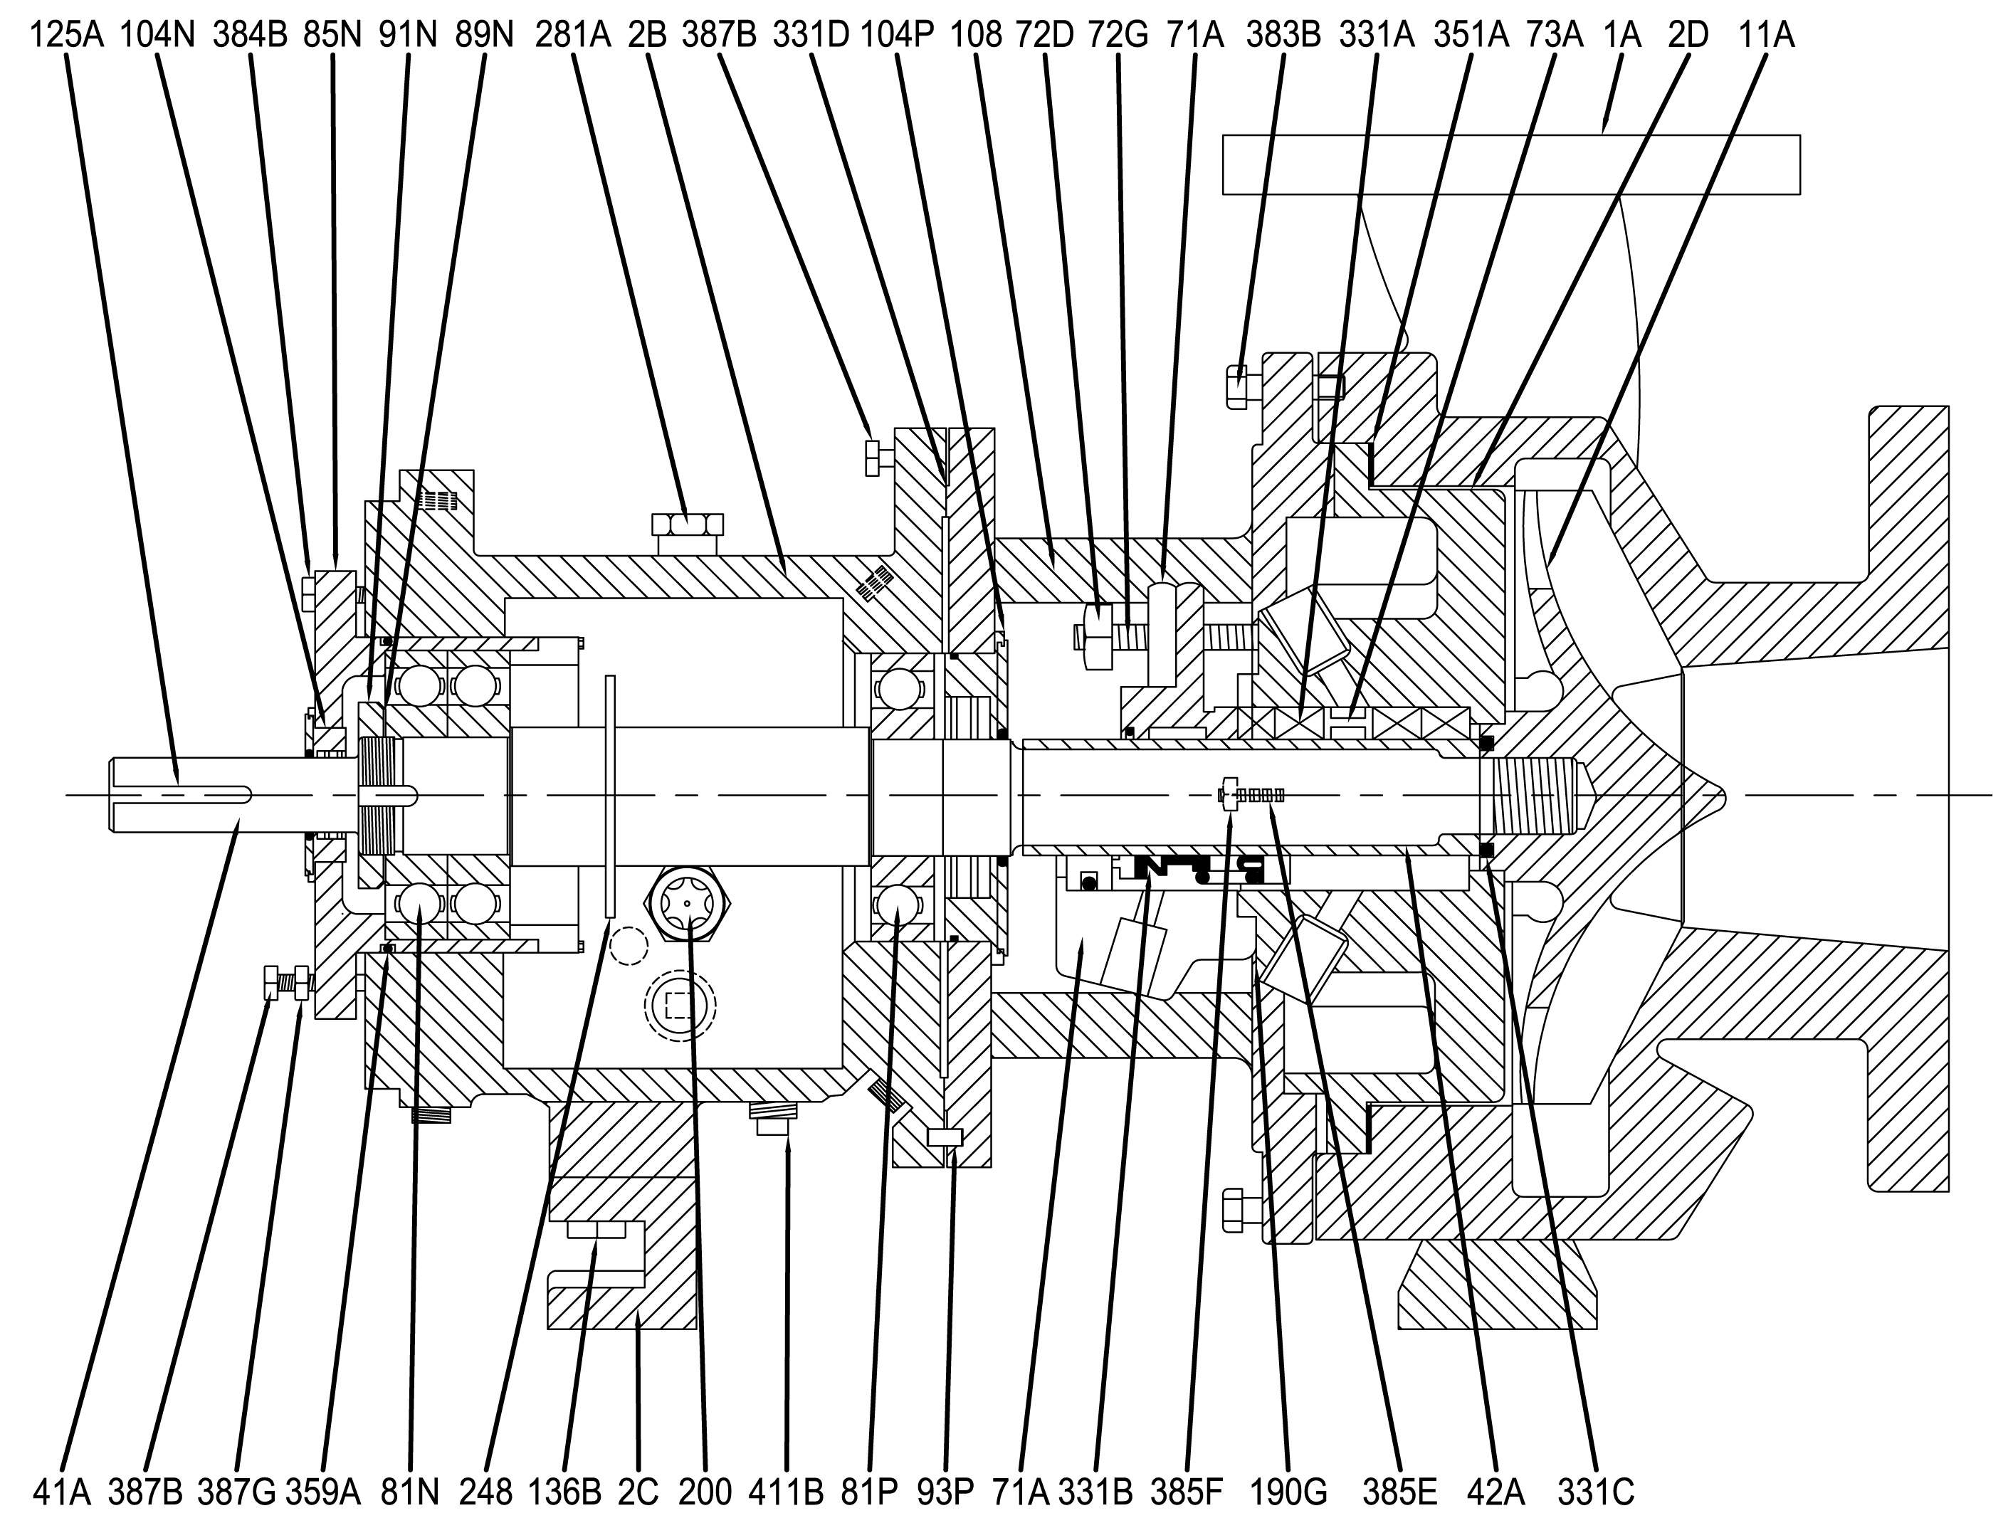

Item Number | Item Description | Num. Req. |  | Item Number | Item Description | Num.  Req.
1A | Casing |  |  | 125A | Coupling Key
2B | Bearing Housing |  |  | 136B | Bearing Housing Foot Capscrew
2C | Bearing Housing Foot |  |  | 190G | Stuffing Box Gland Gasket
2D | Rear Cover |  |  | 200 | Sight Gauge
11A | Impeller |  |  | 201C | Bearing Carrier Retainer
41A | Shaft |  |  | 248 | Oil Thrower
42A | Shaft Hook Sleeve |  |  | 281A | Bearing Housing Vent Plug
71A | Stuffing Box Gland |  |  | 331A | Packing
72D | Gland Nut |  |  | 331B | Mechanical Seal
72G | Gland Stud |  |  | 331C | Impeller O-Ring
73A | Lantern Ring |  |  | 331D | Bearing Housing Gasket
81N | Outboard Bearing, Thrust |  |  | 351A | Casing Gasket
81P | Inboard Bearing, Radial |  |  | 359A | Bearing Carrier O-Ring
85N | Bearing Carrier |  |  | 383B | Casing Bolt
89N | Outboard Bearing Lockwasher |  |  | 384B | Bearing Carrier / Housing Bolt
91N | Outboard Bearing Locknut |  |  | 385B | Casing Jacking Bolt
93P | Bearing Housing Dowel Pin |  |  | 385E | Rear Cover Stud
104N | Outboard Lip Seal |  |  | 385F | Rear Cover Nut
104P | Inboard Lip Seal |  |  | 387G | Bearing Housing Jam Nut
108 | Bearing Housing Adapter |  |  | 411B | Bearing Housing Drain Plug
Recommended spare parts are in BOLD.

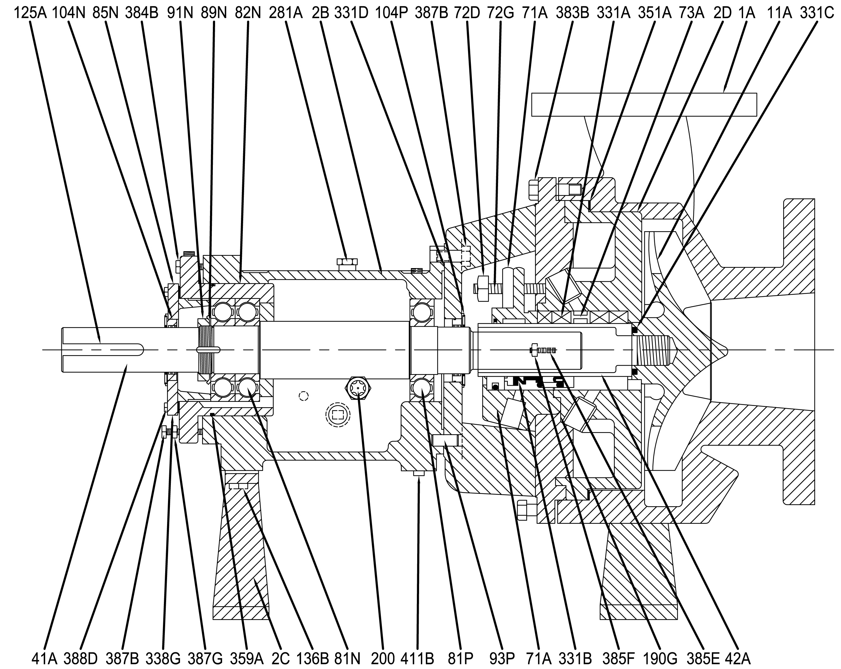

Item Number | Item Description | Num. Req. |  | Item Number | Item Description | Num.  Req.
1A | Casing |  |  | 125A | Coupling Key
2B | Bearing Housing |  |  | 136B | Bearing Housing Foot Capscrew
2C | Bearing Housing Foot |  |  | 190G | Stuffing Box Gland Gasket
2D | Rear Cover |  |  | 200 | Sight Gauge
11A | Impeller |  |  | 201C | Bearing Carrier Retainer
41A | Shaft |  |  | 281A | Bearing Housing Vent Plug
42A | Shaft Hook Sleeve |  |  | 331A | Packing
71A | Stuffing Box Gland |  |  | 331B | Mechanical Seal
72D | Gland Nut |  |  | 331C | Impeller O-Ring
72G | Gland Stud |  |  | 331D | Bearing Housing Gasket
73A | Lantern Ring |  |  | 351A | Casing Gasket
81N | Outboard Bearing, Thrust |  |  | 359A | Bearing Carrier O-Ring
81P | Inboard Bearing, Radial |  |  | 383B | Casing Bolt
82N | Bearing Carrier |  |  | 384B | Bearing Carrier / Housing Bolt
85N | Bearing End Cover |  |  | 385B | Casing Jacking Bolt
89N | Outboard Bearing Lockwasher |  |  | 385E | Rear Cover Stud
91N | Outboard Bearing Locknut |  |  | 385F | Rear Cover Nut
93P | Bearing Housing Dowel Pin |  |  | 387G | Bearing Housing Jam Nut
104N | Outboard Lip Seal |  |  | 388D | Bearing End Cover Capscrew
104P | Inboard Lip Seal |  |  | 411B | Bearing Housing Drain Plug
108 | Bearing Housing Adapter
Recommended spare parts are in BOLD.

Large Taper Bore  Oversized, tapered bore with specially shaped and evenly spaced flow modifiers. Designed for seals with large gland bolt and gasket circles. | • Single internal cartridge seals.  • Dual internal/external cartridge seals.  • Single internal component seals with flexibly mounted seats.*  • Dual internal “true” tandem cartridge seals.  Note: Bypass flush to internal seal normally not required. Barrier fluid or external flush may apply to dual seals (Plans 52, 53, etc.).
Standard Bore  Standard cylindrical bore design for packing arrangements and conventional seals with small gland bolt and gasket circles. | • Dual internal component seals. Isolates the seal chamber from the process. Allows less expensive seal materials. Recommended in tough slurry applications. Allows for thermal convection type flush plans; however, pumping ring devices are recommended.  Note: External Flush Plans 52, 53, 54  • Single internal component or cartridge seals when applied with a throat bushing. Usually selected to increase stuffing box pressure above the vapor pressure to avoid cavitation, etc.  • Usually preferred over the CBL when jacketing is selected for increased effectiveness in cooling or heating.  Note: Applied with Plan 11, etc.
*All seal selections perform best when the faces are located directly within the flush path, particularly if solids, liquors, or slurries are present. Component seals with clamped seat gland designs locate the seal faces reasonably well. Flexibly mounted seat glands should include the vent and drain option to better locate the seal faces. The FML is always the first-choice chamber for maximum self-flush path benefits.

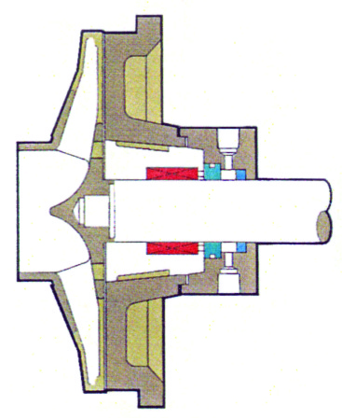

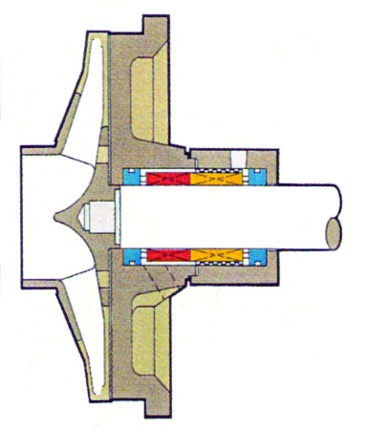


Sales & Marketing: 185 Progress Road • Collierville, Tennessee • 38017
Manufacturing: 185 Progress Road • Collierville, Tennessee • 38017
Phone: (800) 888-7167
Fax: (901) 860-2323
- Your Local Authorized Distributor -

